Title: Fitt’s Law Evaluation
Objectives:
- Be able to manipulate and programmatically access the DOM
- Automatically collect data from interaction with a user interface
- Implement a small web app to evaluate a pointing device
Deliverables:
- Website implementing a study to evaluate Fitts law for an input device
- Evaluation with 3 people
  - Protocol with notes for each person
  - Consent form for each person
  - CSV file with anonymized data for each person
Assignment:
In this assignment, you will create a small web app for using Fitt’s Law to evaluate an input device.
Instructions:
- Make sure you have Node.js, Express, Webstorm, and the latest version of Mozilla Firefox downloaded and installed
  - Node: https://nodejs.org/
  - Webstorm: https://www.jetbrains.com/webstorm/
    - You will need to verify you are a student with JetBrains to get free access to the Webstorm IDE
  - Once you have node installed. You can use NPM (node package manager) to download Express. Instructions are here: https://expressjs.com/
    - To do so, open up a command line on you computer
    - Follow Express’s instructions
- Download the skeleton files with this assignment’s pseudocode from Canvas.
- Choose a device to test. Devices typically tested include:

- Create the views needed to test Fitts law. You will need at least the following 5 views.
  - Instructions to participants – this page introduces the overall idea of testing a pointing device using a target task. Collect basic information about the device being tested, and assign the tested participant and anonymized ID.
  - Instruction page – this page introduces the target task, explains what to do, and shows an example task
  - Training tasks – this page gives example tasks that people can try; I recommend having people try at least 3 tasks as a training period, but you can do more if you’d like.
  - Interim page before trials – this is a landing page for participants to prep before starting. Remind them to hit the target as fast and as accurately as possible.
  - Trials = 15 trials; have participant hit 15 different targets sequentially. Save the data from each trial in a CSV file.
  - Summary page – show the participant their averages and stats from the target task.
Both your training pages and your trials pages should introduce participants to the task of hitting a target of 3 varying sizes and distances like the following:
- You should test 3 angles of approach: 0°, 45°, and 90°.
- You should test 3 sized circles of diameter: 10px, 20px, and 40px.
- You should test 5 distances: 20px, 40px, 80px, 160px, 320px.
Below are some diagrams about how a typical Fitts target task is rendered and evaluated. The first couple of figures show how a set of uniform target sizes are laid out according to the distance being tested. The target should be highlighted with a distinct color to distinguish it from eligible targets. The last two figures show how a task is measured and what are the relevant data to collect about the task. You may choose to collect continuous path information if the information is available to you based on the device you choose to test.
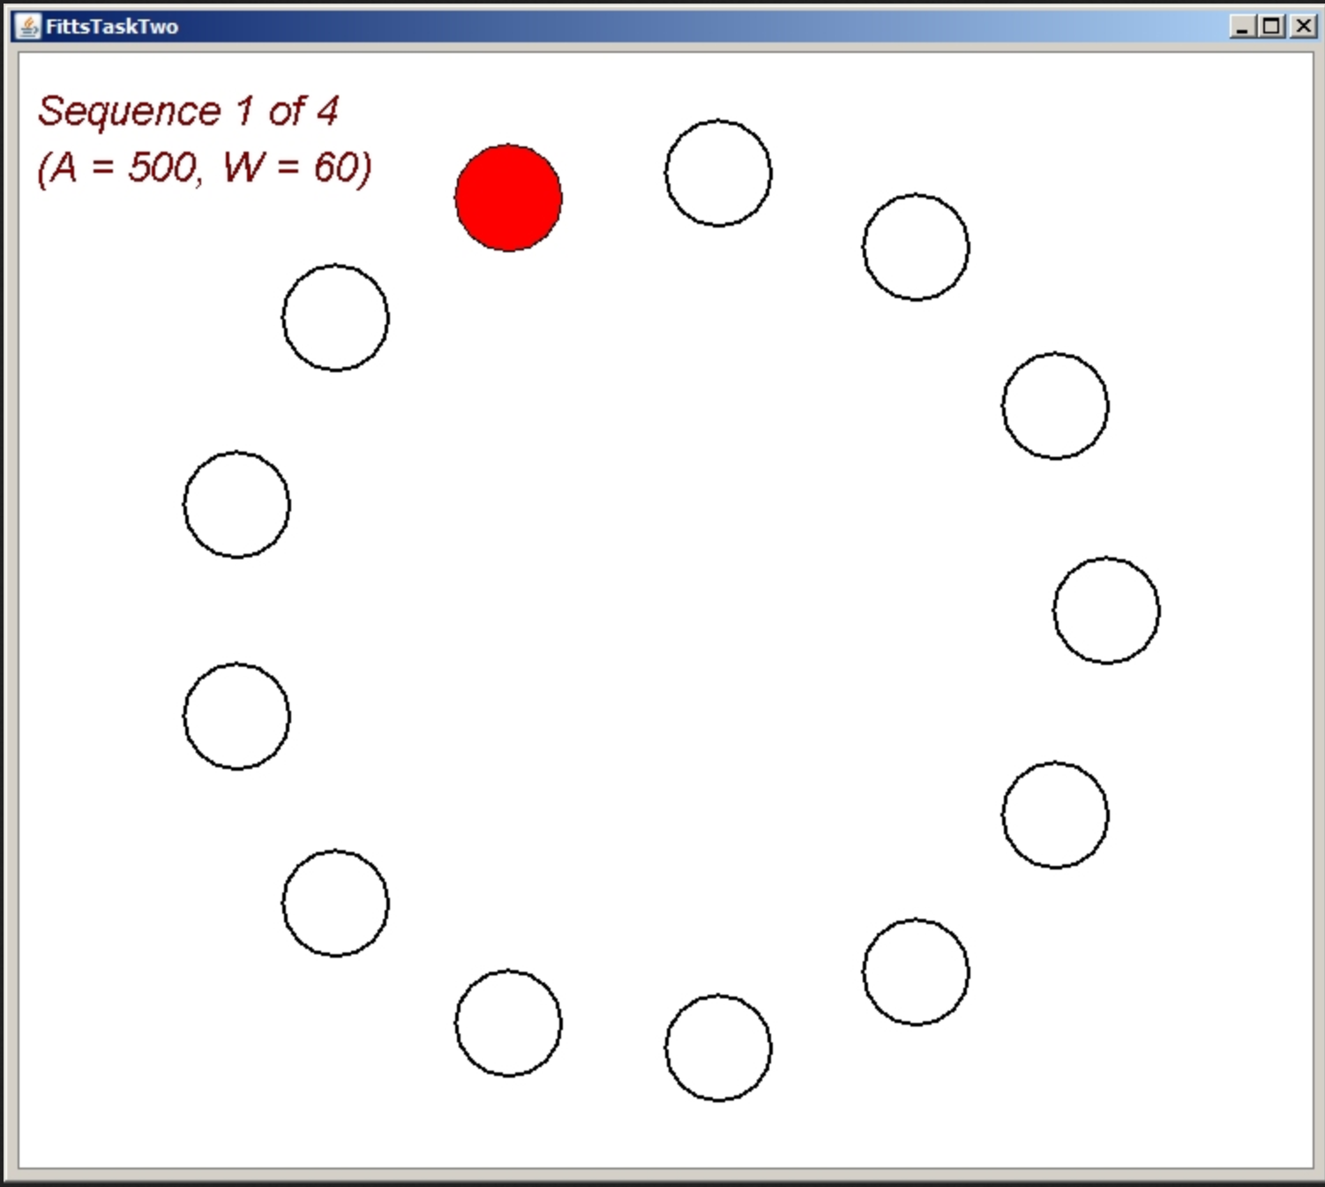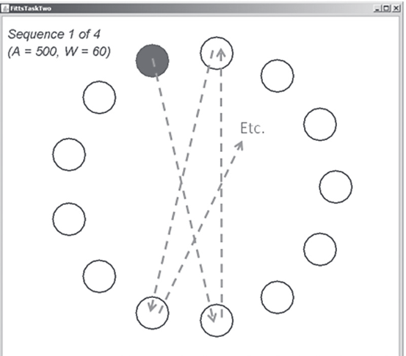
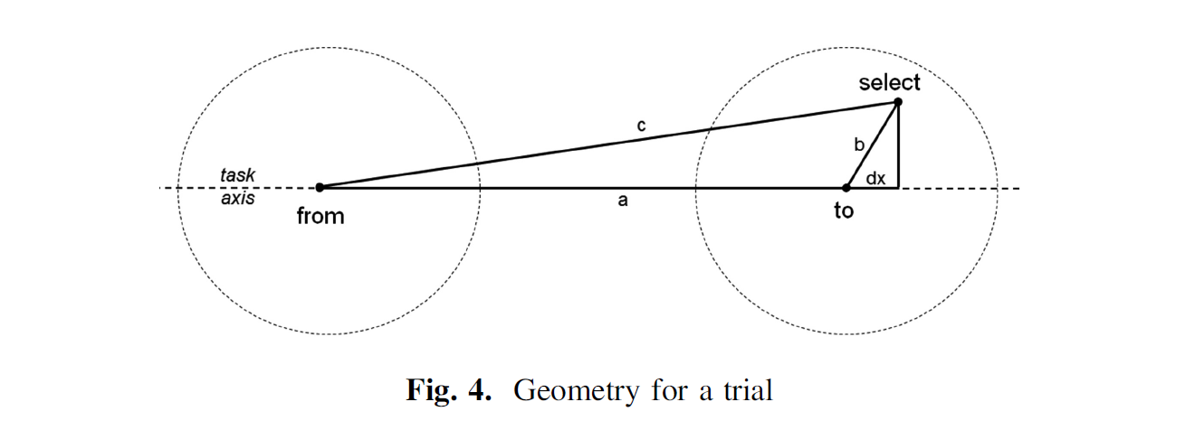

- Each of the 5 views should advance to the next using a button.
- During the training and trials pages, the button to advance should stay hidden until the participant has completed all of the tasks.
- After each target task, collect the statistics on the task and save to a CSV file. These should include the size of the target, the starting position, the ending position, and the time it took for them to hit the target. Any efforts to hit the target that did not land on the target should be recorded as misses, and the related stats should be recorded.
- Setup your node server
  - Use the file main.js to get up and running with Node and Express
  - Use main.js to serve your html pages and to write collected data to a single CSV file for each participant.

